**Month:** January 2019

**Theme:** Healthy resolution: Class 1

**I. Objective of lesson**:

1. Learn how to set healthy goals

2. Develop ways we can stay on track with our goals

3. Learn different ways to be healthy in our lives

**II. Activities and Key learning points: Time: 30 mins**

Activities and Key learning points

Red team (Center based program)

1. Message to Participants- Video
2. Talk and demonstrate the different themes of healthy living curriculum
3. Resolution, healthy heart, Happy Mind and Body, Building Abilities, Fun with food, community around you, Backyard Games, Competition Month, Olympics , MOVE!, Fun with Movement. ( see sheet breaking down themes)
4. Develop Healthy Binder ( see example)
5. Staff write in individuals movement goals Write in Goals for each individual
6. Decorate covers with healthy pictures – cut outs, draw, stickers

Blue team (Center/community based programs)

1. Message to Participants- Video
2. Have a discussion about the different themes of healthy living curriculum

a. Resolution, healthy heart, Happy Mind and Body, Building Abilities, Fun with food, community around you, Backyard Games, Competition Month, Olympics , MOVE!, Fun with Movement. ( see sheet breaking down themes)

1. Develop Healthy Binder ( see example)
2. Write in Goals for each individual
3. Decorate covers with healthy pictures – cut outs, draw, stickers

Green Teams (Community Based)

1. Message to Participants- Video
2. Talk about the different themes of healthy living curriculum
3. Resolution, healthy heart, Happy Mind and Body, Building Abilities, Fun with food, community around you, Backyard Games, Competition Month, Olympics , MOVE!, Fun with Movement. ( see sheet breaking down themes)
4. Ask for ways they can do this in their lives
5. Develop Healthy Binder ( see example of the healthy binder)
6. Write in Goals for each individual
7. Decorate covers with healthy pictures – cut outs, draw, stickers

**IV. Supplies needed**

1. Video to participants
2. Binders set up
3. Stickers, cut outs, magazine ( to cut out),
4. Individual movement goals

V. Feedback on Lesson

1. (Staff inputs)

2. (Individuals input)

3. ( Manager Inputs)

BOOK: (use a double motion)

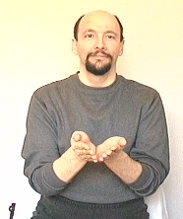

GOAL:  Hold up your base hand in an index finger shape. Aim the index finger of the dominant hand toward the tip of the index finger of the base hand.  Move the dominant hand toward the base hand but do not make contact. Note: the base hand must be somewhat higher than your normal signing area.

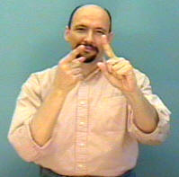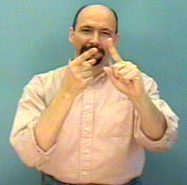

BALL

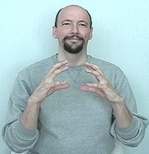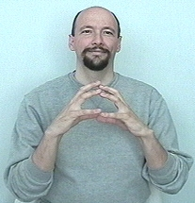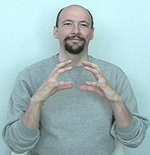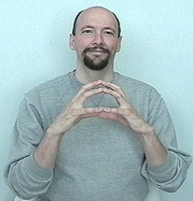

EXERCISE:

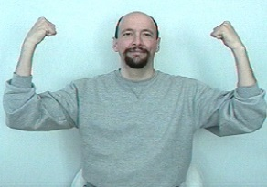

MONTH:

