**Month:** March 2020

**Theme:** Healthy Heart: Lesson 5

**I. Objective of lesson**:

1. Learn why exercise and movement is important for a healthy heart

2. What one can do to have a healthy heart

3. Different ways to move to work the heart

**II. Activities and Key learning points: Time: 30 mins**

Activities and Key learning points

Red team (Center based program)

1. Watch video from the heart association on healthy heart <https://www.pbs.org/video/fit-kids-7-healthy-heart/>
2. Listen to a heart beat <https://www.youtube.com/watch?v=FtXNnmifbhE>
3. Locate and Listen to your Heart beat with a stethoscope or use you had to make the sound on the desk.
4. Color a picture of the heart

Blue team (Center/community based programs)

1. Watch video from the heart association on healthy heart <https://www.pbs.org/video/fit-kids-7-healthy-heart/>
2. Listen to a heart beat <https://www.youtube.com/watch?v=FtXNnmifbhE>
3. Locate and Listen to your Heart beat with a stethoscope or use you had to make the sound on the desk.
4. Show them how to take their pulse on their wrist of neck <https://www.wikihow.com/Check-Your-Pulse>
5. Color a picture of the heart- Label part of the heart <https://www.teachpe.com/anatomy-physiology/the-circulatory-system/the-heart>

Green Teams (Community Based)

1. Watch video from the heart association on healthy heart <https://www.pbs.org/video/fit-kids-7-healthy-heart/>
2. Listen to a heart beat <https://www.youtube.com/watch?v=FtXNnmifbhE>
3. Locate and Listen to your Heart beat with a stethoscope or use you had to make the sound on the desk.
4. Show them how to take their pulse on their wrist of neck <https://www.wikihow.com/Check-Your-Pulse>
5. Color a picture of the heart- Label part of the heart <https://www.teachpe.com/anatomy-physiology/the-circulatory-system/the-heart>

**IV. Supplies needed**

1. Videos
2. Stethoscopes
3. Coloring sheets
4. Markers, crayons

V. Feedback on Lesson

1. (Staff inputs)

2. (Individuals input)

3. ( Manager Inputs)

HEART:

A good general way is to poke your chest twice with the tip of the middle finger of  a modified "five" hand  that has the middle finger bent at the large knuckle.   
If you just poke once using a somewhat larger movement it means "touched" as in "I was touched by his generosity."

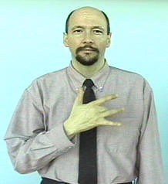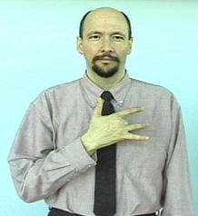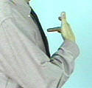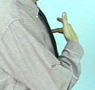

Version two: Draw a heart shape on your chest with the tips of both index fingers.  Start at the top center of the heart.  
Version three:   Instead of using the tips of the index fingers to draw a heart on your chest, use the tips of the middle fingers of modified "five" hands that have the middle fingers bent at the large knuckle.

EXERCISE: The general sign for "exercise" looks somewhat like lifting weights.

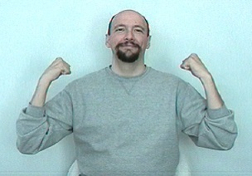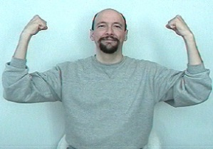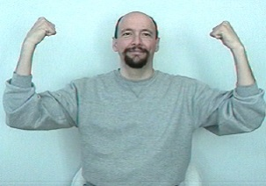

WALK: To do the general sign for "walk," hold your flat hands in front of you and move them as if they were feet in the process of walking.

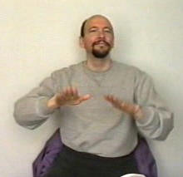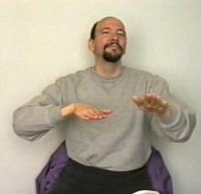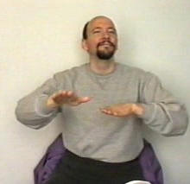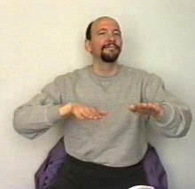

DANCE:   
Memory aid: Think of your feet gliding across the dance floor.

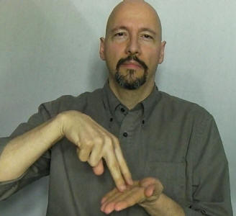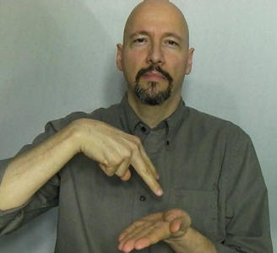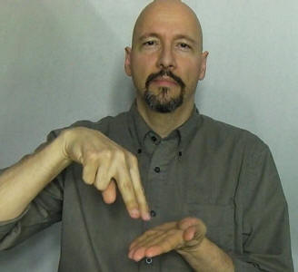

DOCTOR: Tap the letter “D” (for doctor) or “M” (for medical doctor) on wrist where you take your pulse

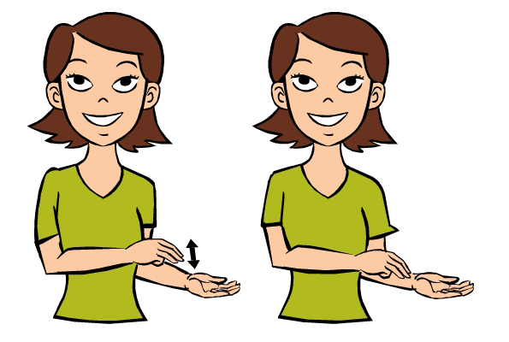 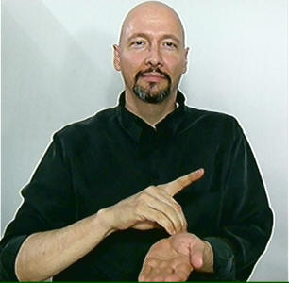

FOOD:

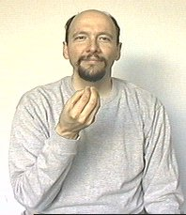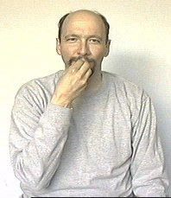

FRUIT: To sign "fruit" touch the tips of the index finger and thumb of an "F"-hand to your cheek. Twist the "F"-hand on your cheek twice.

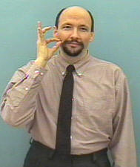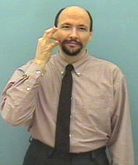

VEGETABLES:

Stick the tip of the index finger of a "V" handshape on my cheek and twist my hand twice.  The "V" pivots on the tip of the index finger.  The middle finger isn't touching the face.

