

A Standard CURRICULUM TO Assess and Teach Safety and Healthy Habits: Preventing THE spread OF Communicable Diseases

Lifetime Assistance Inc.



Table of Contents

1. **HANDWASHING**
   1. Importance and Facts pg. 3
   2. Assessment pg. 5
   3. Coaching Plan for washing hands pg. 6
   4. Supplementary materials/activities for washing hands pg. 6
   5. YouTube Videos pg. 7

1. **PERSONAL PROTECTIVE EQUIPMENT**
   1. Importance and Facts pg. 9
   2. Assessment pg. 11
   3. Coaching Plan for wearing a mask pg. 12
   4. Supplementary materials/activities for wearing a mask pg. 12
   5. YouTube Videos pg. 12

1. **SOCIAL DISTANCING**
   1. Importance and Facts pg. 14
   2. Assessment pg. 15
   3. Coaching Plan for Social Distancing pg. 18
   4. Supplementary materials/activities for learning Social Distancing pg. 18
   5. YouTube Videos pg. 19

**IV.**  **CLEAN ENVIRONMENTS**

* 1. Importance and Facts pg. 20
  2. Assessment pg. 21
  3. Coaching Plan for Cleaning pg. 22
  4. Supplementary materials/activities for learning Social Distancing pg. 22
  5. YouTube Videos pg.23

A Letter to Staff

This training curriculum was developed for all Individuals we support and staff at Lifetime Assistance to promote a safe work/home environment. This curriculum aims to supplement annual and orientation health and safety topics trainings.

The best way to remain safe is to **prevent** contracting diseases. Many people receiving supports and services may have challenges in learning and retaining information associated with following healthy habits. Some people will learn quickly, or might already have the skills to practice healthy habits, and may just need reminders to execute. This curriculum provides individuals and staff a variety of learning and teaching opportunities to ensure ongoing healthy habits.

The curriculum was developed (with best practices in mind) in hopes to make it easier for you to implement strategies of teaching people safety and healthy hygiene skills to prevent illnesses. It is a guide to use for all learning styles/abilities. This is a basic curriculum which will need your knowledge of the people we support to assure it is as successful as possible for each and every person. Thank you!!!

The curriculum will be separated into four different skill areas;

* personal hygiene
* social distancing
* using PPE (personal protective equipment)
* Sanitized and clean environment

There is a simple assessment, for each skill area, to determine a successful starting point and teaching strategy.

You will also find a library of tools accommodate and motivate different learning styles of the person you are teaching/supporting.

It is recommended to read the Agency’s “How to Teach” curriculum if you do not have experience with teaching others.

  

Washing Hands

**Hand Washing**

* Hand washing, for 20 seconds, is a skill that must be practiced and reinforced every day.
* Teaching hand washing and all the steps are crucial.
* Keeping hands clean will avoid getting sick and spreading germs to others.
* We can prevent diseases from spreading by washing hands with soap and running water before meals, after bathroom use, when returning home/to work, when soiled.
* If you can’t wash your hand uses a 60% alcohol-based hand sanitizer.

**Facts:**

* 80% of communicable diseases are transferred by touching your own eyes, nose, mouth, or your food
* Every time a toilet is flushed with the lid up, a fine mist containing bacteria such as E. Coli and Staph is spread over an area of 6 sq. meters. The area around sinks in public bathrooms is 90% covered in such bacteria
* Damp hands are 1000x more likely to spread germs than dry hands.
* School study: children who washed their hands regularly had 51% fewer sick days than those who did not.
* Most bacteria on our hands is on the finger tips and under the nails

**Teaching:**

* Multisensory instruction helps make connections and form memories
* **Visual instruction** may include a visual schedule, poster or sequence cards that reinforce instruction and present the steps or items needed in order to wash hands (i.e., My Healthy Smile, Making Sequences, Hygiene HD)
* **Auditory instruction** may include reading a story about hygiene (i.e., Germs Are Not for Sharing, Wash, Wash, Wash! or No More Germs Please) or singing songs that guide the hand washing sequence (found on YouTube).
* **Tactile instruction** may include games like hygiene bingo, mock handwashing sessions which highlight the manipulation of the soap dispenser, faucet and hand drying equipment.
* **Show (model)** what to do. Show the person how you wash your hands.
* **Practice (repeat)** instructions and modeling as many times as needed before the person understand and can perform the skill.
* **REINFORCE (praise, air hi fives, thumbs up) every attempt the person makes to perform the skill.**
* Some people will need additional training. Please ask clinicians if you are having trouble getting people to wash their hands.

**Tips:**

* Use of a step stool if they can’t reach the sink.
* Determine if an automatic soap dispenser or manual dispenser is suitable.
* Which will meet their sensory preference – Gel soaps, bar soaps or foaming soaps.
* Can they easily reach the paper towel?
* Can they tolerate using a hand dryer with their sensory needs? The loud noise and strong air could over stimulate of be aversive.
* Use a timer (20 seconds), count to 20, sing a song that lasts for 20 seconds

Lifetime Assistance INC Assessment for **WASHING HANDS**

This assessment will assist people to build skills for washing hands independently. Staff should provide this assessment as an observer and document the needed cue for each skill area.

Name: ______________________________________ Date: _____________________

|  |  |  |  |  |  |  |
| --- | --- | --- | --- | --- | --- | --- |
| **Hand washing** | **Independently** | **Standby** | **Gestural** | **Verbal** | **Physical** | **Refused** |
| Turns on water |  |  |  |  |  |  |
| Puts hands under water |  |  |  |  |  |  |
| Applies soap to hands |  |  |  |  |  |  |
| Scrubs Palms (5 sec) |  |  |  |  |  |  |
| Scrubs Back of hands (5 sec) |  |  |  |  |  |  |
| Scrubs between fingers (5 sec) |  |  |  |  |  |  |
| Scrubs both thumbs (5 sec) |  |  |  |  |  |  |
| Rinses soap from hands |  |  |  |  |  |  |
| Obtains a Paper Towel to dry hands |  |  |  |  |  |  |
| Turns water off with Towel |  |  |  |  |  |  |
| Throws paper towel away |  |  |  |  |  |  |
|  |  |  |  |  |  |  |

Assessment completed by: _________________________________________

(print name and title)

Staff will provide assistance as needed to each skill until Independence is reached or if team agrees the person has reach highest potential. Assessment should be completed annually. Different ways of teaching hand washing is within the curriculum. If progress is not seen, a different Staff Action Plan should be made.

Assessment should be saved in shared file.

**Coaching Plan Hand Washing**

|  |  |
| --- | --- |
| **Goals:** | Following a demonstration and practice, person will be able to wash hands independently and if able to vocalize, gesture, sign an understanding of the purpose of proper hand washing. |
| **Materials:** | sink, soap, paper towels – social stories, YouTube |
| **Method** | **Instruct**:  Discuss germs and how germs make people sick. Use pictures, social stories, YouTube.  **Model**:     Show the person how to wash hands for 20 seconds and dry hands, turn the faucet off with paper towel and discard.  Use timers, song,   counting.  **Practice**:  Have the person wash their hands, give directions as needed, verbal, hand over hand or gestural.  **Reinforce:**  Reinforce throughout the process, when participating, when learning a new step. Give praise, no touch hi fives, thumbs up. Thank the person for keeping themselves and everyone else healthy and safe. |
| **Modifications/Accommodations:** | See IPOP and consider sensory needs. |
| **Checking For Understanding:** | As the individual wash hands, staff checks for proper washing technique and provides feedback. |

**Supplementary materials/activities**

**Tips for sensory problems:**

<https://sensoryintegration.org.uk/News/8821506> 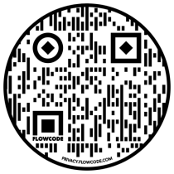

**Glitter fun**   
Put a little glitter or flour on some hands. Have each person touch items around them. When finished, point out the dirty areas. Brainstorm ways to avoid germs and the spread of germs.

**Traveling Germs**

Demonstrate how germs can spread in the air. Take a little bit of corn starch and pretend to sneeze by blowing on it. You can see where the corn starch spreads and understand the importance of covering their mouths when they sneeze. Then ask them what should happen after they sneeze. Show them the “germs” of the corn starch in your hand. Together, brainstorm a list of times when people should wash their hands. This will help them to practice healthy hand washing habits.

**Ah-choo!**

Design a tissue box or paper towel display that reminds people to wash their hands. Why should people wash their hands? When should people wash their hands? How should people wash their hands? These are questions that can be addressed in their designs. Individuals can share their projects and then display them in the bathrooms.

**Potato Germs**

Slice a potato, and blanch it to kill any germs that may be on the potato already. Before people have washed their hands, have them each handle a small slice of potato. Then, have them wash their hands using proper technique and handle another potato slice. Put each slice in a separate, labeled plastic bag. After about five days, have them draw both slices in their science notebooks. What is different between the potato slices? Why do they think the slices are different?

**PEPPER Experiment**

Sprinkle the pepper onto the surface of the water. It will float. Tell them that the pepper represents germs.

Ask them to dip one finger gently into the water to see what will happen to the pepper. Nothing happens – just like not much happens when they give their hands a cursory dip under a running tap when washing their hands. Take their finger out of the water, dry it and coat it with hand soap. Now have them dip their finger again into the water. What happens to the pepper? Magic, right!

### **Bread Experiment**

This experiment shows the science behind *why* it’s important for people to wash their hands by showing ‘hidden’ aspects of microorganisms. It will take about 5-7 days to see the full effects of the germs on the bread. For this experiment, you’ll need three pieces of bread and three zippered plastic bags, and a marker.

1. Label the bags with these labels: control, clean hands, and dirty hands.

2. Use tongs to put a piece of bread in the bag labeled “control.” Next, have people touch the second piece of bread BEFORE they wash their hands and place it in the bag labeled “dirty hands.”

3. Have people wash their hands and then touch the last piece of bread and place it in the bag labeled “clean hands.”

Have them predict what will happen to each bag. Then, observe the pieces of bread each day and discuss what they see.

**Cinnamon Hands Activity**

Now, people can put their hand washing skills to the test with the cinnamon hands activity.

Sprinkle cinnamon on a flat surface like a plate. Then, pat hands in the cinnamon. Front and Back.

Next, explain how this is similar to germs and allergens that gather on their hands during the day, that they can’t see. Now, their job is to wash their hands and try to get all of the cinnamon off.

**Catchy Rap Song: Can be fun to watch and learn a new tune**

<https://youtu.be/J-GcC_cgSHM> 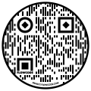

<https://youtu.be/Z7rpaSvnntY> 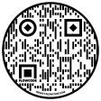

**Drawing How and When to wash hands**

<https://youtu.be/0GwpIDnu_gc> 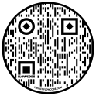

**CDC: Formal videos showing how to wash hands**

<https://youtu.be/d914EnpU4Fo> 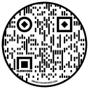

<https://youtu.be/z87EIgmssBQ> 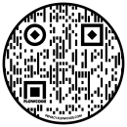

<https://youtu.be/i_Fs0Qrtu90> 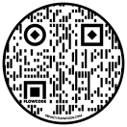

**Animated: Cartoon to help grab attention**

<https://youtu.be/4f65IzxfIWM> 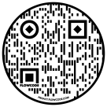

<https://youtu.be/7QKrFxahFC4> 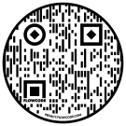

Experiments/black light

<https://youtu.be/8YiN4tFVA9E> 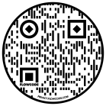

<https://youtu.be/3SfHdSHK-g0> 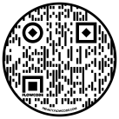

<https://youtu.be/ZquWcf7DInQ> 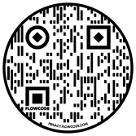

**Soap silly putty**

<https://youtu.be/kQ55A00YQrs> 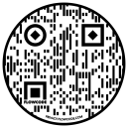

work sheet

<http://www.glogerm.com/sheets/grade4.pdf>

<http://www.glogerm.com/sheets/grade3.pdf>

<http://www.glogerm.com/sheets/grade2.pdf>

<http://www.glogerm.com/sheets/grade1.pdf>

Useful items<https://classroom.kidshealth.org/classroom/prekto2/personal/hygiene/germs.pdf>

  

**Personal Protection Equipment**

**Types of PPE**

Let's first start talking about the **three G's -- gloves, gowns and goggles**. **Gloves** are worn to protect your hands when handling dirty items and potentially touching body fluids. This is the number one PPE you will use a lot in a healthcare environment. **Gowns** are worn over your clothes and uniforms. Germs can even live on them and be transferred other places. Gowns can keep you clean when you are exposed to body fluids and dirty items. **Goggles** protect your eyes from the body fluids that can potentially splash in your eyes. The next two types of PPE both cover your nose and mouth but have different ways they protect you from certain germs. **Masks** protect you from splattered body fluids. They are called surgical or procedural masks. **Face Masks** help prevent the spread of illness that is primarily transmitted in the air. **Respirators** protect you from airborne germs by filtering the air you breathe. There are several different types and some have to be specifically measured to fit your face in order for them to be effective.

**Face Masks and Sensory Processing Disorders:**

* Breathing = Nervous System Regulator – This can affect their ability to self-regulate especially if they feel they can’t breathe they will take more shallow breaths. Remind them even with the mask on they are still getting air.
* Tactile = Sense of Touch. The masks can be irritating to our folks. Perhaps a gaiter style with neoprene or stretchy fabric that will provide more firm pressure would be more acceptable.
* Olfactory = Sense of Smell - Smelling their own breath may be aversive to them and with the mask on that is what you smell. We can scent the masks with diluted essential oils that are safe to inhale.
* Proprioception = Where body is in space – They may not be refusing to put it on but simply don’t know where there body parts are and can’t motor plan the action.
* Emotional Regulation – Trying to keep them calm will have an impact on how well they do.
* Impulsivity –They may take them off without thinking simply because of impulsivity. Frequent reinforcement will be important.
* **NOTE:** If a person is unable to remove the mask themselves, or communicate that they want the mask removed, they should not wear a mask, unless directed by a medical team.

**Ways to Encourage Mask Wearing:**

* Instruct as to why we are wearing masks, use social stories and educational YouTube segments.
* Make it a habit/requirement to wear in the van and on all outings.
* Let them express what they like or dislike about wearing the mask.
* Model wearing a mask for them.
* Have their favorite stuffed animal wear one to make it fun.
* Practice wearing them even if you don’t need to. Time for a mask drill.
* Make a game out of wearing them and see who can do it the longest.
* Include them in choosing what type feels best to them.
* Provide breathable fabric that isn’t itchy.
* Get masks that have favorite characters or activities on them.
* Ear attachments – find alternative, i.e. buttons on a head band or baseball cap, gaiter style, tie behind head.
* Reinforce (PRAISE) for wearing the mask. Comment on how safe, cool, they look. Thank people for helping people stay safe.

**Types of Masks:**

**Neck Gaiter:** Might be more tolerated by those with sensory defensiveness.

DIY: <https://www.youtube.com/watch?v=AD9vfMvQ3ko> 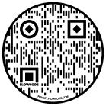

Assessment for

**PPE Mask**

This assessment will assist people to build skills for washing hands independently. Staff should

provide this assessment as an observer and document the needed cue for each skill area.

Name: ______________________________________ Date: _____________________

|  |  |  |  |  |  |  |  |
| --- | --- | --- | --- | --- | --- | --- | --- |
| **Mask** | **Independently** | **Standby** | **Gestural** | **Verbal** | **Physical** | **Refused** | **NA** |
| Knows to wash hands |  |  |  |  |  |  |  |
| Picks up Mask |  |  |  |  |  |  |  |
| Puts Mask over nose |  |  |  |  |  |  |  |
| Pulls strings behind ear |  |  |  |  |  |  |  |
| Ties/pulls Strings behind head |  |  |  |  |  |  |  |
| Lowers Mask below chin |  |  |  |  |  |  |  |
| Demonstrates when to use a mask |  |  |  |  |  |  |  |
| Wears the Mask part time |  |  |  |  |  |  |  |
| Wears the Mask when needed |  |  |  |  |  |  |  |

Assessment completed by: _________________________________________

(print name and title)

Staff will provide assistance as needed to each skill until Independence is reached or if team agrees the person has reach highest potential. Assessment should be completed annually. Different ways of teaching hand washing is within the curriculum. If progress is not seen, a different Staff Action Plan should be made. Assessment should be saved in shared file.

* **NOTE:** If a person is unable to remove the mask themselves, or communicate that they want the mask removed, they should not wear a mask, unless directed by a medical team.

|  |  |
| --- | --- |
| **Goals:** | Following a demonstration and practice, person will be able to wear a mask independently and if able to vocalize, gesture, sign an understanding of  the purpose of wearing a mask |
| **Materials:** | Mask, social stories, YouTube |
| **Method** | **Instruct**:  Discuss germs and how germs make people sick. Use pictures, social stories, YouTube.  **Model**:  Show the person how wear a mask (see assessment tool)  **Practice**:  Have the person wear mask, give directions as needed, verbal, hand over hand or gestural.  **Reinforce:**  Reinforce throughout the process, when participating, when learning a new step. Give praise, no touch hi fives, thumbs up. Thank the person for keeping themselves and everyone else healthy and safe. |
| **Modifications/Accommodations:** | See IPOP and consider sensory needs. |
| **Checking For Understanding:** | As the individual wears mask, staff checks for proper fit and provides feedback. |

**Supplementary materials/activities**

**To wearing a mask**

**Create your own design**

Materials needed: fabric paint and cloth masks. Personalize a mask

**Add a Mask**

The group will cut out faces out of a magazine. Glue or tape them on a poster board. Once done, provide various size cut out masks (out of paper) that can be used to cover the faces correctly (over the nose and mouth)

**Make your own mask**

DIY Materials needed: cotton material and a sewing machine. No sew instructions included

<https://www.sciencebuddies.org/stem-activities/DIY-face-mask#instructions> 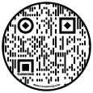

**Overcome Sensory Issues (long and for staff only)**

<https://youtu.be/VoYgythZB-I> 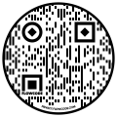

**Social Story (animated)**

<https://youtu.be/lnP-uMn6q_U> 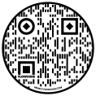

<https://youtu.be/mhCBXlPPOuw> 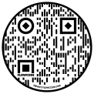

<https://youtu.be/uR_Uy6icYtc> 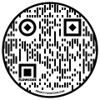

<https://youtu.be/IMakd_YF8dU> 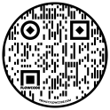

<https://youtu.be/alDe9GCf8Sw> 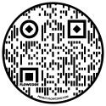

**how to wear a mask**

<https://youtu.be/wCYXyU-mzqk> 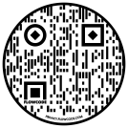

**Sign language included**

<https://youtu.be/IkHEyjPGG8A> 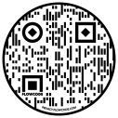

**The Guardian gloves and mask**

<https://youtu.be/4xFY3aPF7E4> 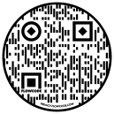

**Mask**

<https://youtu.be/PwYapjQUVmo> 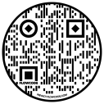



**The today shows dos and don’ts**

<https://www.today.com/video/how-to-wear-face-masks-properly-and-how-to-clean-them-82331205710> 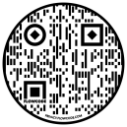

**Proper way**

<https://www.youtube.com/watch?v=LiO1B5hWS2g> 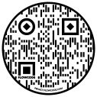

**Social Distancing**

**Social Distancing and Why It’s Important to Maintain**

The Centers for Disease Control (CDC) encourages everyone to stay home and avoid non-essential travel. If you must go in public for essentials, practice social distancing that is, maintaining physical space around you.

Social and physical distancing is currently recommended by our health care professionals to lessen the chance of catching a communicable disease such as COVID-19. Communicable diseases such as COVID 19 spreads person to person. This means the more people are in close contact with each other, the more the virus has a chance to spread.

* **Stay least 6 feet away** **from others**.
* **Stay away from large groups, including at a friend’s house, parks, restaurants, shops or any other place.**
* **Staying out of crowded places**.
* **Always wear you mask/face covering**.

Social Distancing doesn’t mean disconnecting. For many of us, COVID-19 has disrupted our routines, and it’s important to stay connected with family and friends during this challenging time.

* Connect with loved ones through video calls, phone calls, texts or social media.
* Unless you are showing signs of illness or have tested positive for COVID-19, go outside to exercise and walk pets while keeping at least 6 feet from others.

Lifetime Assistance Inc.

Assessment for

**Social Interactions Distancing**

This assessment will assist people to build skills to understand Social Distancing. Staff should provide this assessment as an observer and document the needed cue for each skill area.

Name:____________________________________________________ Date:____________________

Does the person have a medical condition or behaviors that would interfere with social distancing? Explain:____________________________________________________________________________________________________________________________________________________________________

|  |  |  |  |  |  |  |
| --- | --- | --- | --- | --- | --- | --- |
| Skill | Independent | Standby | Gestural | Verbal | Physical | Refused |
| Knows when they are ill? |  |  |  |  |  |  |
| Is able to stay away from others? |  |  |  |  |  |  |
| Look towards or otherwise indicates a person in the immediate area? |  |  |  |  |  |  |
| Is able to understand simple directions? |  |  |  |  |  |  |
| Is able to understand the direction to “step back” |  |  |  |  |  |  |

Assessment Completed By: ______________________________________________________________

(print name and title)

Staff will provide assistance as needed to each skill until Independence is reached or if team agrees the person has reach highest potential. Assessment should be completed annually. Different ways of teaching social distancing is within the curriculum. If progress is not seen, a different strategy should be implemented. Assessment should be saved in a shared file.



**COVID -19**





**Help prevent the spread of the coronavirus**



**SOCIAL DISTANCING**



**and your**

**PERSONAL SPACE BUBBLE**



**Keep 6 feet between you and the other person whenever possible.**

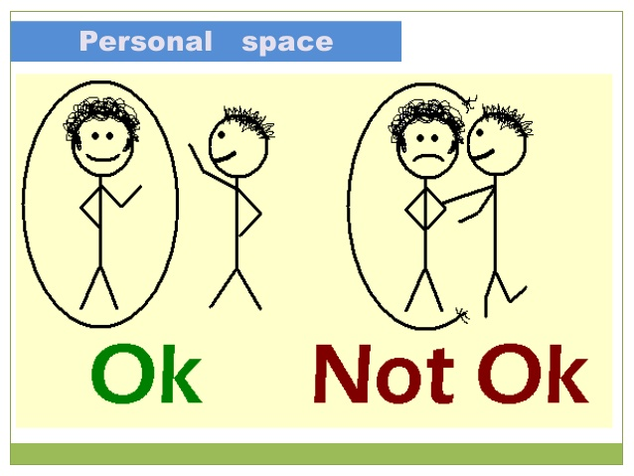

SOCIAL DISTANCING =

keeping one’s distance away from another to

 help prevent the spread of a communicable disease

**Coaching Plan: Social Distancing**

|  |  |
| --- | --- |
| **Goals:** | Following demonstration and practice, the person will be able to independently demonstrate how to socially distance. |
| **Materials:** | 6 foot length of string/yarn. Social Distancing and Your Personal Space Bubble poster |
| **Method** | **Instruct:** Discuss germs and how germs make people sick. Use pictures, social stories, YouTube videos, etc.  **Model:** Show the person how to socially distance yourself from others. Show the person what 6 feet looks like by using a string/yarn cut to length.  **Practice:** Have each person practice standing at one end of the string and another person stand at the opposite end. Point to the distance between each other and further discuss the importance.  **Reinforce:** Reinforce throughout the process, when participating, when learning a new step. Give praise, no touch hi-five, thumbs-up. Thank the person for keeping themselves and everyone else healthy and safe. |
| **Modifications/Accommodations:** | See IPOP |
| **Checking For Understanding:** | As the person demonstrates and/or explains what social distancing is, staff will provide feedback. |

**Supplementary materials/activities to support Social Distancing**

**Have fun coming up with ways to practice and learn how to social distance:**

* Using items to show 6 feet gives visual and physical awareness to how far 6 feet is. Use additional items to demonstrate the distance. Such as pillows, books, shoes, balls, etc. Making a game of trying to figure out how many items its takes to stay 6 feet from each other.
* The Space Bubble**:** Using a hula hoop, hold it around your waist and then walk around the space, seeing when their hula hoops bump. That is likely where someone’s personal space bubble would be. If you get much closer, the other person would probably be uncomfortable (make sure the hula hoops are not too big).
* Sitting Down Space Bubble**:** You will need a lot of string or yarn to do this activity, or you can use a long jump rope and share it.  Have everyone sit down and give them the string, yarn or rope. Let each person demonstrate their personal space bubble by arranging the string, yarn or jump rope around them, forming a circle whatever size they want.  Look at everyone’s space bubbles.  Are some bigger/smaller than others?
* My Comfort Zone**:** As with Red Light / Green Light, one person is standing across the room and the others are on the opposite side.  This game works best if you have only one person advance forward toward the person across the room.  The person who is demonstrating their space bubble should put their hand up using the “STOP” signal, when the person walking toward them gets close enough.  Any closer and the person would be uncomfortable.  Take a look at each person’s space bubble as you play.

   

**Video is animated using smile faces referred to as dots. Clear message given regarding social distancing or physical distancing. 2:29 minutes.**

<https://youtu.be/9csvnEpeSrI> 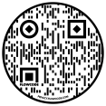

**Video is animated using graphs, explain specific things that can be done to stay healthy. 1:16 minutes**

<https://youtu.be/8x20vBOkGNY> 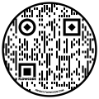

**Video is black & white animated, using medical professionals. Practicing SD, why it’s important, quite thorough. 2:15 minutes**.

<https://www.youtube.com/watch?v=XP_Q1x5BjQo> 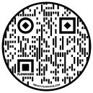

**Video is animated, explains how sickness spreads, when an infected person gets too close. Stay 6 feet apart-SD. 2:11 minutes**

<https://www.youtube.com/watch?v=QtNZZWLdoeo> 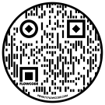

**What SD means using cut-out pictures. There are no voices (music). The pictures show examples, comical. 1:22 minutes.**

<https://www.youtube.com/watch?v=oLsRhNBRJeM> 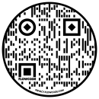

**Clean Environments**

A main goal of the Agency is to teach independence. Teaching skills to maintain a clean and healthy environment is essential to promote healthy living. This chapter is about the importance of disinfecting all areas that could be dirty. Use the check list for ideas. Some items need hourly cleaning and some may only need monthly.

Things to keep in mind:

* **Life threatening: Be aware of the risk of using cleaning products (PICA, mouthing behaviors). Listed in IPOP.**
* No matter what the skill level, everyone can be involved.
* A clean and disinfected environment protects everyone and is the responsibility of **all of us** in the area.
* Frequent short cleaning times makes the environment easier to keep clean.
* Minimize the germs that are spread in your environment by eliminating objects that attract germs. Sofas, carpets, and bean bag chairs are breeding grounds for germs and allergens.
* Get a tightly woven carpet instead of a plush carpet or opt for a vinyl bean bag chair that can be wiped down easily.
* Assign each person a job, from wiping down areas to cleaning out the trash and recycle bin.
* Make cleaning part of the daily routine, people we support learn through repetition.
* Material that is needed: Talk to OT/PT for adaptive devices (large cleaning rubber gloves –should not be shared, paper towels, scrub Brushes, Broom/dust pan, Mop Bucket)

Agency’s Cleaning Procedures



Lifetime Assistance INC

Assessment for **Cleaning**

This assessment will assist people to build skills for cleaning their environment independently. Staff should provide this assessment as an observer and document the needed cue for each skill area.

Name: ______________________________________ Date: _____________________

People with mouthing or PICA behaviors should not have access to cleaning solutions

|  |  |  |  |  |  |
| --- | --- | --- | --- | --- | --- |
| **Cleaning** | **Independently** | **Standby** | **Gestural** | **Verbal** | **Physical** |
| Understands the dangers of cleaning (sanitize) solutions |  |  |  |  |  |
| Gathers cleaning supplies (rag, paper towel, mop, broom) |  |  |  |  |  |
| Able to apply the cleaning agent |  |  |  |  |  |
| Cleans own area after meals (dish to sink, wipe table) |  |  |  |  |  |
| Able to uses a Broom |  |  |  |  |  |
| Able to uses a Mop |  |  |  |  |  |
| Able to Dust |  |  |  |  |  |
| Routine cleaning (door knobs, light switch, hard chairs) |  |  |  |  |  |
| **Comments:** | | | | | |

Assessment completed by: _________________________________________

(print name and title)

Staff will provide assistance as needed to each skill until Independence is reached or if team agrees the person has reach highest potential.

**Coaching Plan for Cleaning**

|  |  |
| --- | --- |
| **Goals:** | Following a demonstration and practice, person will be able to clean areas of their room and/house independently and if able to vocalize, gesture, sign an understanding of the purpose of proper cleaning and sanitation. |
| **Materials:** | Defend Cleaning spray, gloves, paper towels – social stories, YouTube |
| **Method** | **Instruct**:  Discuss germs and how germs make people sick. Discuss that regular cleaning, especially high contact/frequently touched surfaces decreases the spread of germs. Use pictures, social stories, YouTube.  **Model**:     Show the person the Defend cleaning spray bottle, to wear gloves, and how to wipe down high contact/frequently touches surfaces thoroughly.  Use the cleaning protocol checklist to review what high contact/frequently touched surfaces are (light switches, television remote controls, CD players, Door handles, Drawer handles, closet, door handles, wash bedding frequently and whenever soiled, table tops, desks, chairs ,table top activity item such as peg boards, puzzles, crafting items).  **Practice**:  Have the person clean areas of their room from the cleaning protocol checklist, give directions as needed, verbal, hand over hand or gestural.  **Reinforce:**  Reinforce throughout the process, when participating, when learning a new step. Give praise, no touch hi fives, thumbs up. Thank the person for keeping themselves and everyone else healthy and safe. |
| **Modifications/Accommodations:** | See IPOP and consider the risk of providing cleaning products to the people we support. This should be listed within the IPOP. The dangers of not knowing could mean life or death. |
| **Checking For Understanding:** | As the individual cleans, staff checks for proper cleaning technique, and provides feedback. |

**Supplementary materials/activities**

Some ways to motivate people to clean (most are self-explained)

1. How fast can you do it Count out loud and enthusiastically to see how long it takes them to clear off or clean area.
2. Use a countdown timer with alarm. Tell them ready set gooooo….help them by pointing out what needs to be done
3. Who can pick up the most? Little competition
4. Messy table clean up- Use non menthol shaving cream on table tops to use as finger paint. It will loosen dried glue after doing arts and crafts
5. Dance to music. Double activity…exercise and cleaning.
6. Role model. Have them follow you around the home to find dirty surfaces
7. You spray cleaner and they wipe it off (be aware of toxic items)

**Videos on germs spreading**

<https://youtu.be/uf9UwQT0-fo> 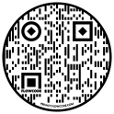

<https://youtu.be/04sFxbqf6Sk> 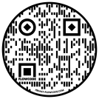

<https://youtu.be/ZgIMA5TVEoE> 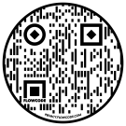

**Hotel inspections. Yuck**

<https://youtu.be/EcTuhKz5Cgo> 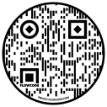

**How to make your own UV light**

<https://youtu.be/W0_ILzGxEfQ> 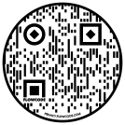

Take the light around the room/house to see what needs to be cleaned.

Material that is needed: Talk to OT/PT for adaptive devices

Large cleaning rubber gloves-should not be shared

Cleaning agents

Paper towels

Scrub Brushes

Broom/dust pan

Mop/Bucket

Group/Individual ideas/tips to help teach

1. Identifying the list of material above.
2. Identifying different cleaning agents and what they are used for
3. Teachable moments: spills on the floor
4. Allow independence for each activity, you will need patience
5. Squirt guns are always fun to help clean the tables and surfaces. Use soapy water.
6. Clean the item Game: staff gives clues on the item that needs to be cleaned. Example the door handle…clue is this is used to open doors? Light needs to be dusted…. clue is this item helps you see at night.
7. They might only be able to do the activity with hand over hand assistance. That’s ok. Provide practice as much as possible.